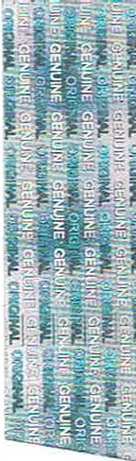

* **CERTIFICATION**

**iii EURO PE™**

# This is to certify that the

**Quality Management System**

# Of

**BioCore Environmental Ltd.**

At

# 14 Par k lands Office Park , Southern Cross Road, Bray, Co. Wicklow

Has been assessed by Certification Europe and deemed to comply with the requirements of

**ISO 9001:2015**

# This certificate is valid for the act iv ities specified below:

**The development and operation of Anaerobic Digestion renewable energy plants and Sludge/Waste Management**

Certification of Registrat ion remains the property of Certification Europe Lt d.

The validit y of this Certificate is maintained on the condition that the Management System is assessed through an on-go ing surve illance programme and continues to adequately meet the requirements of the standard .

To v erify this certificate validity please contact us at info @certificationeurope .com

Date of Initial Certificat ion : 26 th March 2014 This Certificate is valid unt il: 23d' Februar y 2026

# Managing Director: Edel Murphy

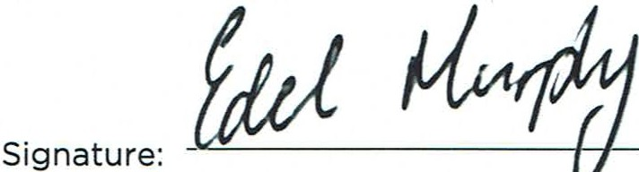

Client Reg istrat ion No.. 2014 / 1864 Certificate Reference No.: A/6

th

Date of certificate issue: 8 Febr uary 2023

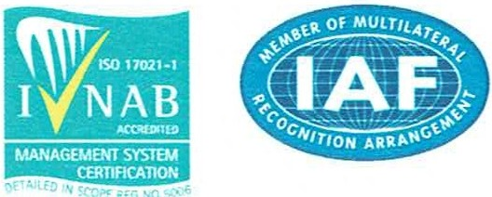**ISO**

**9001**

CERTIFICATION EUROPE

Cert ification Europe Ltd Block 20A Beckett Way, Park West Busin ess Park , Dublin 12, Ireland